FOR IMMEDIATE RELEASE

January 8th, 2021

Baton Rouge Health District to Launch COVID SAFE
Vaccination Promotion Campaign
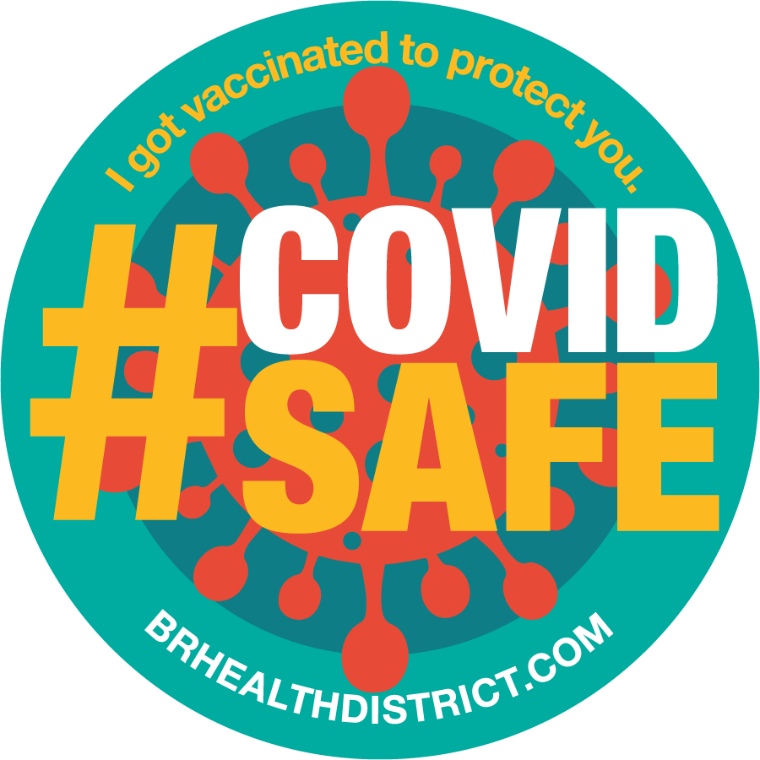
BATON ROUGE, LA – The Baton Rouge Health District is excited to announce its COVID SAFE vaccine promotion campaign. This coordinated outreach effort among Baton Rouge Health District member healthcare institutions will focus on COVID-19 vaccine promotion and engagement, with healthcare providers and caregivers showing leadership in the community as vaccines roll out.
“As healthcare leaders in the Baton Rouge area, we are excited that the COVID-19 vaccines are being given and an end to this global pandemic is within reach. That said, we know it will take time to make the COVID-19 vaccines available to the general public. We want to share messages of hope and encouragement to keep everyone informed so they feel safe, prepared and ready to get their vaccines as soon as they can.” said Steven Ceulemans, Executive Director for the Baton Rouge Health District.
As recently announced by the Health District, all major hospitals have successfully started vaccinating their front-line healthcare workers against COVID-19. A compilation video of these successful, ongoing vaccinations across area hospitals has recently been released and is available at https://youtu.be/WR3FzqS0Sgc .
Those who received their first vaccine dose will start returning for their second and final doses for maximum protection against COVID-19 this week. As the first healthcare workers complete their vaccinations and vaccination programs continue to expand across the Capital Region, those healthcare heroes who are taking the lead in protecting patients, themselves, and their community from the spread of the virus will get COVID SAFE T-shirts to show their support for getting as many people as possible vaccinated.
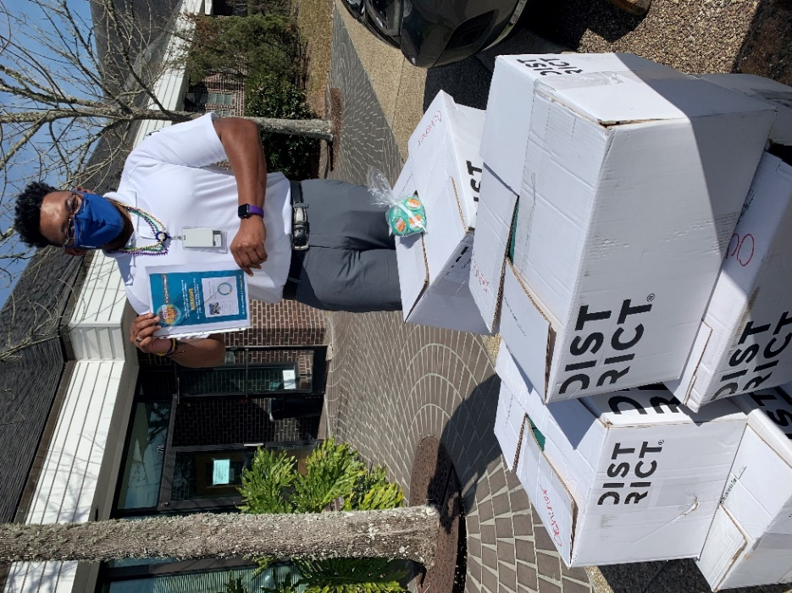 | 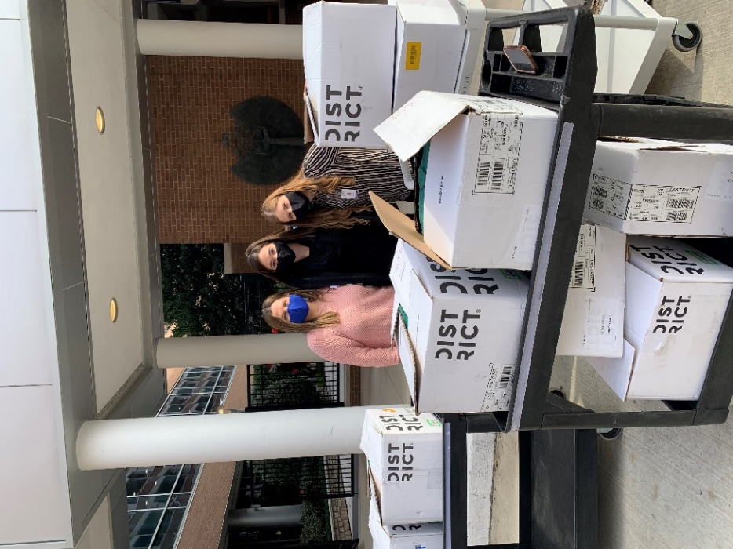
Area healthcare heroes are receiving COVID SAFE T-shirts to show their support for getting as many people as possible vaccinated.
A supportive media campaign including print and social media as well as digital marketing will continue to share information on how vaccination is making area hospitals “COVID SAFE.” Information is available real-time at www.brcovidsafe.com and using the #COVIDSAFE social media hashtag.
The COVID SAFE campaign will be implemented by Baton Rouge Health District and overseen by a committee of communications leaders of all Health District member institutions, which include Ochsner Health System, Mary Bird Perkins Cancer Center, Our Lady of the Lake Regional Medical Center, Baton Rouge Area Foundation, Woman’s Hospital, Pennington Biomedical Research Center, Baton Rouge General Medical Center, and Blue Cross and Blue Shield of Louisiana.
The Baton Rouge Health District has a successful record in regional healthcare stakeholder engagement, including COVID-19 response. Over the past year, the organization has been a key partner for a number of COVID response initiatives including rapid-turnaround molecular COVID testing in partnership with the LSU School of Veterinary Medicine, a community-wide pandemic childcare partnership for first responders and essential healthcare workers in partnership with the Capital-area YMCA, and a coordinated personal protective equipment (PPE) donation and supply hub to assist area hospitals in connecting with alternative supply sources.

Media Toolbox and Social Media Frames available at: https://batonrougecovidsafe.squarespace.com/s/COVIDSAFE-Logos-and-Guidelines.zip
https://brcovidsafe.com/s/COVIDSAFE-Social-Media-Frames.zip

About the Baton Rouge Health District
The Baton Rouge Health District is a coalition of patient-focused, innovative healthcare organizations committed to the vision of a world-class, high performing health destination at the heart of a healthy and vibrant community. As a non-profit organization, the Health District promotes collaboration among healthcare providers, government officials, payors, higher education institutions and others to implement a master plan that will enhance healthcare and economic development in Baton Rouge. Founding members of the Baton Rouge Health District include Baton Rouge Area Foundation, Baton Rouge General Medical Center, Blue Cross Blue Shield of Louisiana, Mary Bird Perkins Cancer Center, Our Lady of the Lake Regional Medical Center, Ochsner Health Systems, Pennington Biomedical Research Center at Louisiana State University and Woman’s Hospital. More information is available at http://brhealthdistrict.com/
###

